Design and Implementation of an FPGA-Based Real-Time UART Command Processing and Response Generation System
The latest version of the project has been successfully developed and verified using Verilog HDL in Xilinx Vivado 2024.1. The design is implemented on an Artix-7 FPGA and provides a complete UART-based command processing system. The FPGA receives commands from a computer through a UART interface, processes the commands in hardware, performs the required operation, and sends an appropriate response back to the computer.
The project is modular in design, making it easy to understand, debug, and expand. Each function of the system is implemented as an independent Verilog module and integrated through a top-level module. The latest source code includes improvements in UART communication reliability, command validation, response generation, and clock management.
The source code consists of the following modules:
- uart_controller_top.v – Top-level module that integrates all project components.
- uart_rx.v – Receives serial UART data and converts it into 8-bit parallel data.
- uart_tx.v – Transmits response data from the FPGA to the computer through UART.
- uart_command_parser.v – Stores incoming characters, validates commands, and generates command codes.
- uart_controller.v – Executes the decoded command and controls the system outputs.
- uart_response_generator.v – Generates response messages such as ACK, ERROR, and STATUS.
- clk_wiz_0 – Clock Wizard IP that converts the onboard 24 MHz clock into a stable 50 MHz system clock.
- constraints.xdc – Contains FPGA pin assignments and timing constraints.
- fpga_uart_terminal.py – Python-based command-line application used for sending commands and receiving responses over the serial port.
The current implementation supports UART communication at 115200 baud, predefined command recognition, real-time command execution, and reliable response generation. The design has been verified through simulation in Vivado and tested on the FPGA board using the Python terminal interface.
Project Overview:
The FPGA-Based Real-Time UART Command Processing and Response Generation System is designed to establish reliable serial communication between a computer and an FPGA using the Universal Asynchronous Receiver/Transmitter (UART) protocol. The project demonstrates how digital hardware can receive commands from a host computer, process them in real time, execute the corresponding operation, and transmit an appropriate response back to the user.
The system is implemented using Verilog Hardware Description Language (HDL) on an Artix-7 FPGA. Unlike microcontroller-based systems, where communication and processing are performed sequentially in software, the FPGA implements the complete communication protocol directly in hardware. This enables faster execution, deterministic timing, and improved reliability.
A Python-based Command-Line Interface (CLI) is used as the user interface. The user enters predefined commands such as ON, OFF, STATUS, or RESET, which are transmitted to the FPGA through a UART connection operating at 115200 baud. The FPGA receives these commands, validates them using a command parser, executes the requested operation, and generates a response such as ACK, ERROR, or STATUS. The generated response is then transmitted back to the computer and displayed on the Python terminal.
To ensure accurate UART communication, the onboard 24 MHz clock is converted into a stable 50 MHz system clock using the Xilinx Clock Wizard IP. The design follows a modular architecture consisting of a UART Receiver, Command Parser, Controller, Response Generator, and UART Transmitter. This modular approach simplifies testing, debugging, and future enhancements.
The project demonstrates fundamental concepts of FPGA design, including finite state machines (FSMs), serial communication protocols, hardware-based command processing, and real-time digital system implementation. It also serves as a foundation for more advanced FPGA-based embedded systems used in industrial automation, robotics, communication systems, and hardware control applications.
Key Features:
- Hardware implementation using Verilog HDL
- Real-time UART communication at 115200 baud
- 24 MHz to 50 MHz clock generation using Clock Wizard
- Hardware-based command parsing and execution
- Python-based command-line interface for user interaction
- Modular architecture for easy maintenance and scalability
- Low-latency and deterministic hardware operation
- Easy integration with future FPGA-based applications

Architecture:
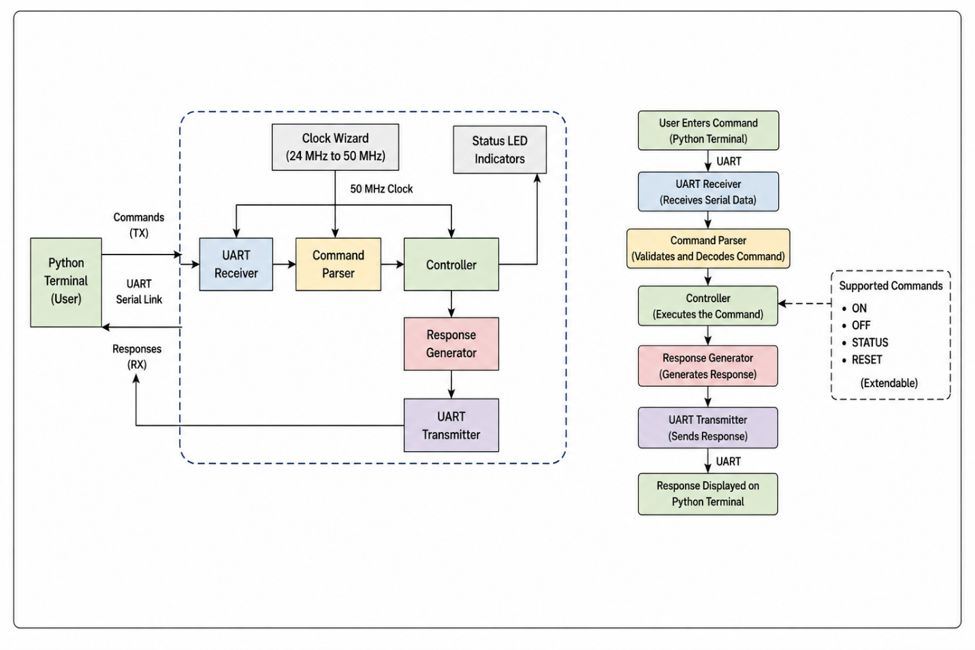
Latest Working Updated Source Code:
The latest version of the project has been successfully developed and verified using Verilog HDL in Xilinx Vivado 2024.1. The design is implemented on an Artix-7 FPGA and provides a complete UART-based command processing system. The FPGA receives commands from a computer through a UART interface, processes the commands in hardware, performs the required operation, and sends an appropriate response back to the computer.
The project is modular in design, making it easy to understand, debug, and expand. Each function of the system is implemented as an independent Verilog module and integrated through a top-level module. The latest source code includes improvements in UART communication reliability, command validation, response generation, and clock management.
The source code consists of the following modules:
- uart_controller_top.v – Top-level module that integrates all project components.
- uart_rx.v – Receives serial UART data and converts it into 8-bit parallel data.
- uart_tx.v – Transmits response data from the FPGA to the computer through UART.
- uart_command_parser.v – Stores incoming characters, validates commands, and generates command codes.
- uart_controller.v – Executes the decoded command and controls the system outputs.
- uart_response_generator.v – Generates response messages such as ACK, ERROR, and STATUS.
- clk_wiz_0 – Clock Wizard IP that converts the onboard 24 MHz clock into a stable 50 MHz system clock.
- constraints.xdc – Contains FPGA pin assignments and timing constraints.
- fpga_uart_terminal.py – Python-based command-line application used for sending commands and receiving responses over the serial port.
The current implementation supports UART communication at 115200 baud, predefined command recognition, real-time command execution, and reliable response generation. The design has been verified through simulation in Vivado and tested on the FPGA board using the Python terminal interface.
Project Overview:
The FPGA-Based Real-Time UART Command Processing and Response Generation System is designed to establish reliable serial communication between a computer and an FPGA using the Universal Asynchronous Receiver/Transmitter (UART) protocol. The project demonstrates how digital hardware can receive commands from a host computer, process them in real time, execute the corresponding operation, and transmit an appropriate response back to the user.
The system is implemented using Verilog Hardware Description Language (HDL) on an Artix-7 FPGA. Unlike microcontroller-based systems, where communication and processing are performed sequentially in software, the FPGA implements the complete communication protocol directly in hardware. This enables faster execution, deterministic timing, and improved reliability.
A Python-based Command-Line Interface (CLI) is used as the user interface. The user enters predefined commands such as ON, OFF, STATUS, or RESET, which are transmitted to the FPGA through a UART connection operating at 115200 baud. The FPGA receives these commands, validates them using a command parser, executes the requested operation, and generates a response such as ACK, ERROR, or STATUS. The generated response is then transmitted back to the computer and displayed on the Python terminal.
To ensure accurate UART communication, the onboard 24 MHz clock is converted into a stable 50 MHz system clock using the Xilinx Clock Wizard IP. The design follows a modular architecture consisting of a UART Receiver, Command Parser, Controller, Response Generator, and UART Transmitter. This modular approach simplifies testing, debugging, and future enhancements.
The project demonstrates fundamental concepts of FPGA design, including finite state machines (FSMs), serial communication protocols, hardware-based command processing, and real-time digital system implementation. It also serves as a foundation for more advanced FPGA-based embedded systems used in industrial automation, robotics, communication systems, and hardware control applications.
Implementation Approach:
The proposed system is implemented using Verilog Hardware Description Language (HDL) on an Artix-7 FPGA using Xilinx Vivado 2024.1. The implementation follows a modular design methodology, where each functional block is developed, tested, and integrated independently. This approach improves readability, simplifies debugging, and allows future expansion of the system.
Initially, the onboard 24 MHz clock is converted to a stable 50 MHz system clock using the Xilinx Clock Wizard IP. The generated clock is used to synchronize all hardware modules, ensuring accurate UART timing and reliable communication.
A Python-based Command-Line Interface (CLI) is developed using the PySerial library to provide communication between the computer and the FPGA. The user enters predefined commands such as ON, OFF, STATUS, or RESET. These commands are transmitted serially to the FPGA through the UART interface operating at 115200 baud.
Inside the FPGA, the UART Receiver continuously monitors the serial input line. When a valid start bit is detected, it samples the incoming data bits, reconstructs the transmitted character, and stores it as an 8-bit parallel value. The received characters are then forwarded to the Command Parser.
The Command Parser collects the received characters until the end of the command is detected. It compares the received command with the predefined command set and generates a corresponding command code if a valid match is found. Invalid commands are identified and flagged for appropriate error handling.
The decoded command is processed by the UART Controller, which performs the requested operation by updating the appropriate control signals. After execution, the Response Generator creates a suitable response message such as ACK, ERROR, or STATUS based on the execution result.
Finally, the UART Transmitter converts the response into serial data and transmits it back to the computer. The Python terminal receives the response and displays it to the user, completing the communication cycle.
The complete design was verified through functional simulation in Vivado before generating the bitstream and programming the FPGA. Hardware testing confirmed reliable command reception, correct command execution, and accurate response generation over the UART interface.
Implementation Flow:
Power ON FPGA

24 MHz Clock → Clock Wizard → 50 MHz System Clock

Python Terminal Sends UART Command

UART Receiver

Command Parser

UART Controller

Response Generator

UART Transmitter

Python Terminal Displays Response

Module Description:
The proposed system is divided into several functional modules, each responsible for a specific task in the UART communication process. The modular architecture improves readability, simplifies debugging, and allows individual modules to be tested independently before integration.
Clock Wizard:
The Clock Wizard is a Xilinx IP core used to generate the system clock required by the UART modules. The FPGA board provides a 24 MHz onboard clock, which is converted into a stable 50 MHz clock. The Clock Wizard also generates a locked signal that indicates when the output clock is stable and ready for operation. All other modules in the system operate using this synchronized 50 MHz clock.
Function:
- Converts 24 MHz input clock to 50 MHz.
- Generates a stable system clock.
- Provides the locked signal.
UART Receiver:
The UART Receiver is responsible for receiving serial data transmitted from the computer. It continuously monitors the UART RX line for a start bit. Once detected, it samples the incoming data bits according to the configured baud rate and reconstructs the received character into an 8-bit parallel format. After successfully receiving a character, the module generates a data-valid signal indicating that new data is available.
Function:
- Receives serial UART data.
- Detects start and stop bits.
- Converts serial data into 8-bit parallel data.
- Generates a data-valid signal.
Command Parser:
The Command Parser processes the characters received from the UART Receiver. It stores incoming characters until the complete command is received. The received command is then compared with a predefined list of valid commands such as ON, OFF, STATUS, and RESET. If a valid command is detected, the parser generates the corresponding command code; otherwise, it flags the command as invalid.
Function:
- Stores received characters.
- Detects the end of a command.
- Validates commands.
- Generates command codes.

UART Controller:
The UART Controller receives the decoded command from the Command Parser and performs the required operation. Depending on the received command, it updates the control signals or internal system status. The controller acts as the decision-making unit of the design and coordinates communication between different modules.
Function:
- Executes decoded commands.
- Controls system outputs.
- Coordinates overall system operation.
Response Generator:
The Response Generator prepares an appropriate response after command execution. Based on the execution result, it generates messages such as ACK for successful execution, ERROR for invalid commands, or STATUS for status requests. These responses are forwarded to the UART Transmitter.
Function:
- Generates acknowledgment messages.
- Generates error messages.
- Creates system status responses.
UART Transmitter
The UART Transmitter converts the response message generated by the Response Generator into serial data. It adds the required UART start and stop bits before transmitting the data through the UART TX line to the computer. This completes the communication cycle.
Function:
- Converts parallel data into serial data.
- Adds UART framing bits.
- Transmits responses to the computer.

Python Command-Line Interface (CLI)
A Python-based Command-Line Interface (CLI) is developed using the PySerial library to communicate with the FPGA. It allows the user to enter predefined commands, transmits them over the UART interface, and displays the responses received from the FPGA. This interface provides a simple and efficient method for testing and interacting with the hardware.
Function:
- Sends UART commands to the FPGA.
- Receives FPGA responses.
- Displays communication results to the user.
Build Instructions:
The FPGA design is developed using Xilinx Vivado 2024.1 and programmed onto an Artix-7 FPGA. The following steps are used to build the project:
- Launch Xilinx Vivado 2024.1.
- Open the existing FPGA project.
- Verify that all Verilog source files, IP cores (Clock Wizard), and the XDC constraint file are added to the project.
- Set uart_controller_top.v as the top module.
- Run Synthesis to check the design for syntax and logic errors.
- Run Implementation to map the design onto the FPGA resources.
- Generate the Bitstream after successful implementation.
- Connect the Artix-7 FPGA board to the computer using a USB cable.
- Open Hardware Manager in Vivado.
- Program the FPGA with the generated .bit file.
After successful programming, the FPGA is ready to communicate through the UART interface.
Run Instructions:
Once the FPGA is programmed, the following steps are performed to run the system:
- Power ON the FPGA board.
- Verify that the Power LED is ON.
- Verify that the Locked LED is ON, indicating that the Clock Wizard has generated a stable 50 MHz clock.
- Connect the FPGA board to the computer through the USB-UART interface.
- Open a command prompt or terminal.
- Navigate to the directory containing the Python application.
- Execute the Python program:
python fpga_uart_terminal.py
- Ensure that the correct COM port and baud rate (115200 baud) are selected.
- Enter one of the predefined commands, such as:
ON
OFF
STATUS
RESET
- Observe the response displayed on the Python terminal.
Testing Instructions:
The functionality of the system is verified through both simulation and hardware testing.
Functional Simulation:
- Simulate the Verilog modules using the Vivado Simulator.
- Verify UART reception and transmission.
- Check command parsing and response generation.
- Ensure correct operation of all finite state machines (FSMs).
Hardware Testing:
After programming the FPGA, perform the following tests:
Test Case | Input Command | Expected Result
Valid Command | ON | FPGA executes the command and returns ACK
Valid Command | OFF | FPGA executes the command and returns ACK
Status Request | STATUS | FPGA returns the current system status
Reset Command | RESET | FPGA resets the controller and returns ACK
Invalid Command | ABC | FPGA returns ERROR
Clock Verification | — | Locked LED remains ON
UART Communication | Any valid command | Data is successfully transmitted and received without errors
Expected Output:
- The Python terminal displays the response generated by the FPGA.
- The Locked LED remains continuously ON, indicating stable clock generation.
- The FPGA correctly processes all valid commands and returns the appropriate response.
- Invalid commands are rejected with an ERROR response.

